

**TEAM ID : NM2023TMID10569**

**PROJECT REPORT**

**TRACING THE GROWTH OF THE GLOBAL COMMUNITY**

**A POPULATION FORECASTING ANALYSIS**

**1.INTRODUCTION**

* 1. OVERVIEW
* A population forecasting gives a picture of what the future size and structure of the population by sex and age might look like. It is based on knowledge of the past trends, and, for the future, on assumptions made for three components: fertility, mortality and migration.
* The world’s population is the total number of humans currently living. It was estimated by the United Nations to have exceeded eight billion in mid-November 2022.



1.2 PURPOSE

* The purpose of population forecasting is to forecast the future population of the global community and to estimate the basic need for human demands such as food, water, power, transportations and so on.
* Population analysis is needed to identify problems and community needs, establish goals and objectives, access alternative courses of action, allocate resources for plan implementation, and evaluate the ability of the plan to achieve goals and objectives.

**2. PROBLEM DEFINITION AND DESIGN THINKING**

2.1 EMPATHY MAP

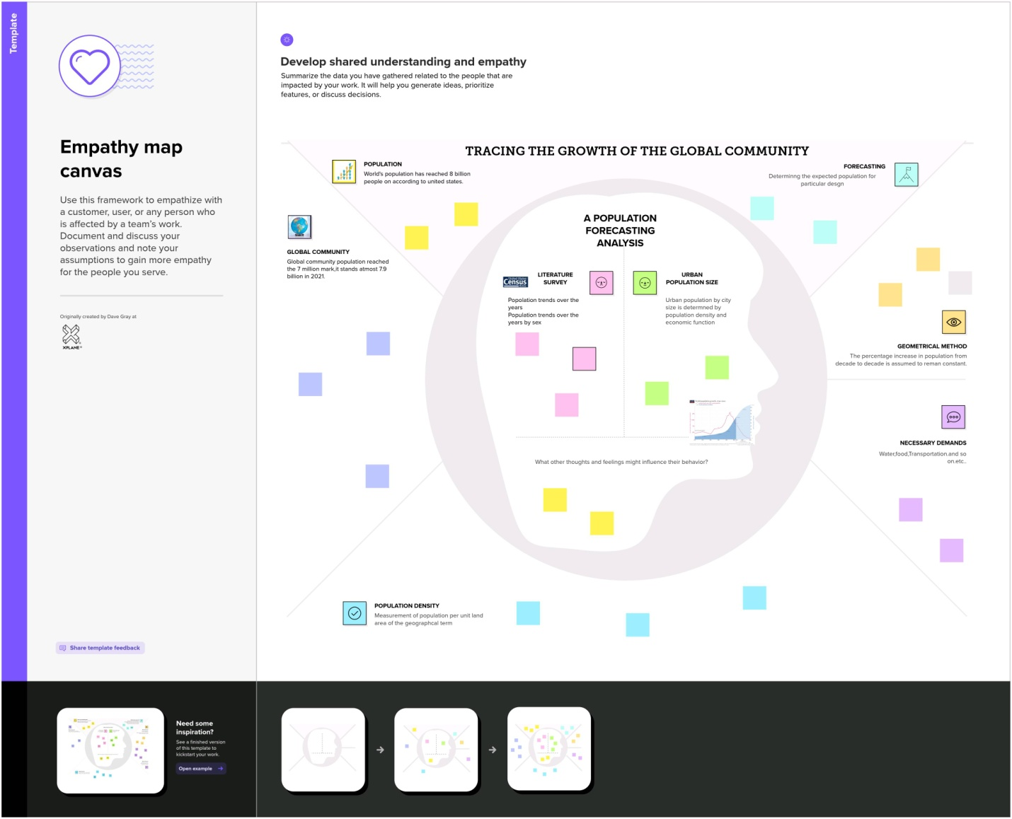



2.2 TDEATION AND BRAINSTORMING

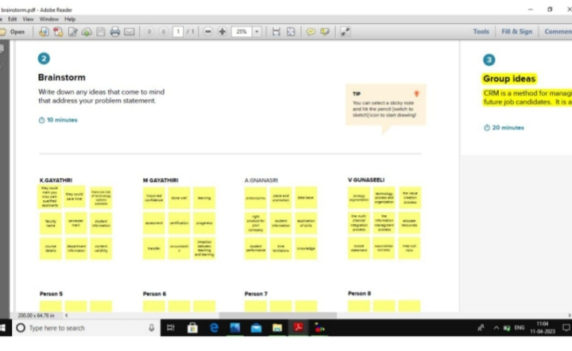

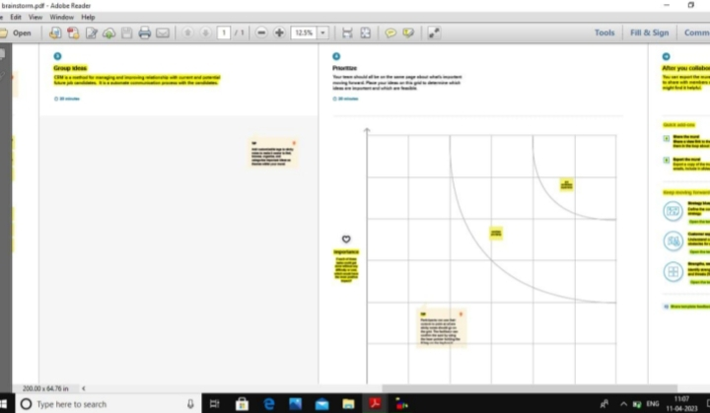

**3. RESULT**

**MILESTONE 1 :** ( LITERATURE SURVEY)

A literature survey is a method of researching existing literature and studies related to a specific topic. In the context of ‘Tracing the growth of a global community’ a literature survey would involve reviewing studies and articles that have been published on the topic of population and demographics, as well as studies specific population increase in cities, The literature survey would include sources such as academic journals, industry reports,



and online articles. It would aim to identify key performance indicators.

**MILESTONE 2 :** (DATA COLLECTION & EXTRACTION FROM DATABASE)

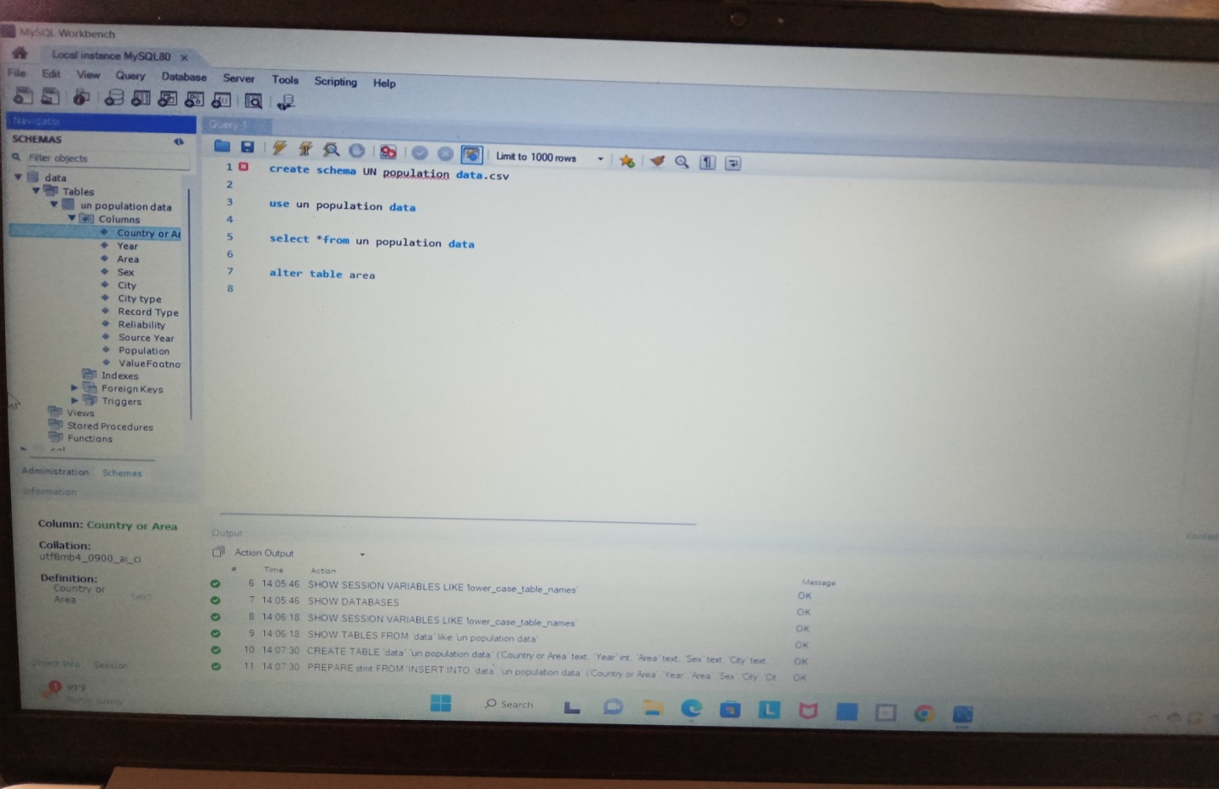

Data collection is the process of gathering and measuring information on variables of interest, in an established systematic



fashion that enables one to answer stated research questions, test hypotheses, and evaluate outcomes and generate insights from the data.

**MILESTONE 3 :** (DATA PREPARATION)

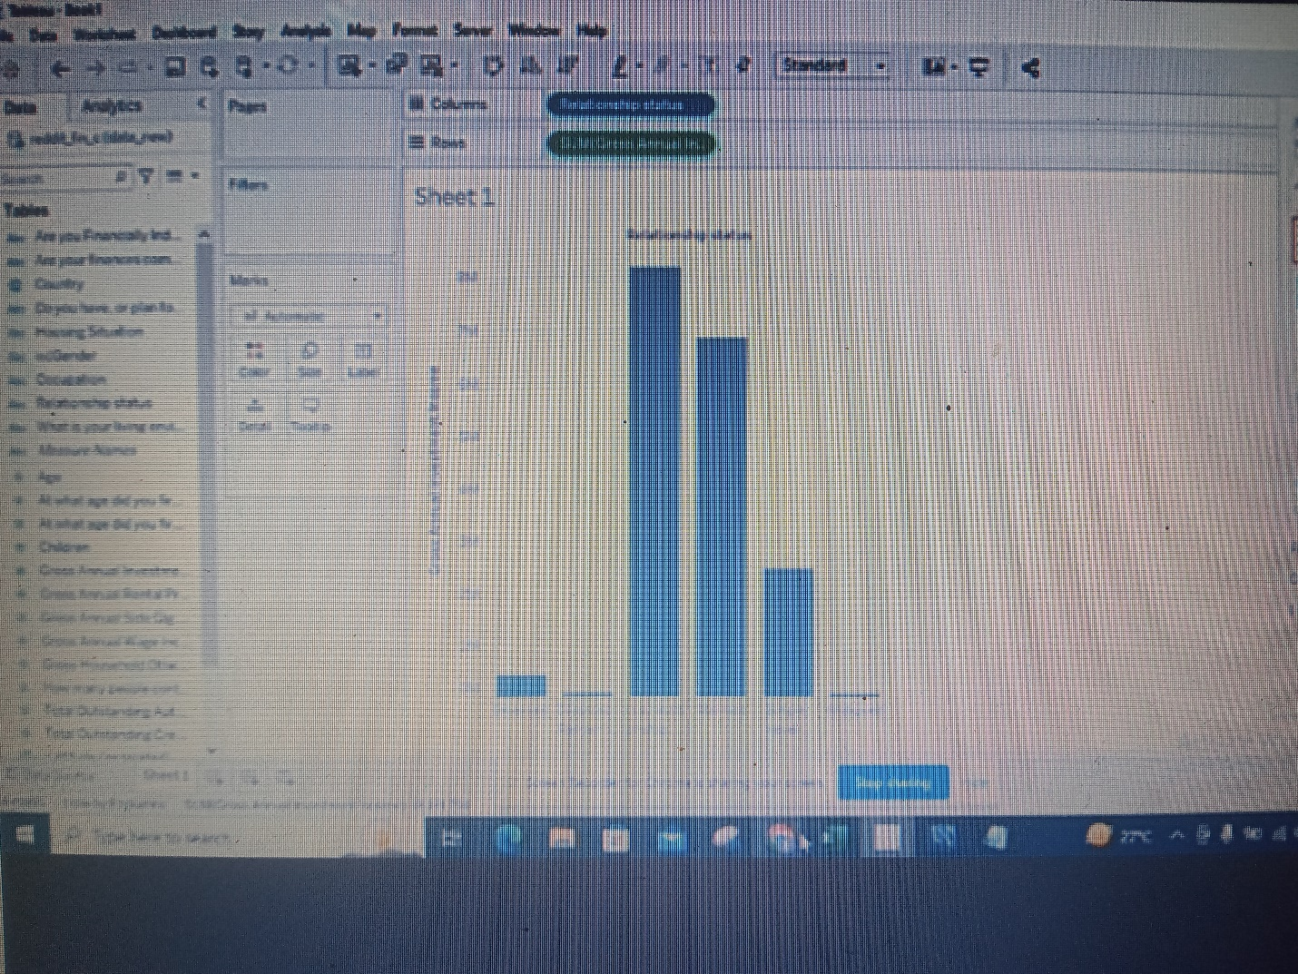



**MILESTONE 4 :** (DATA VISUALIZATION)

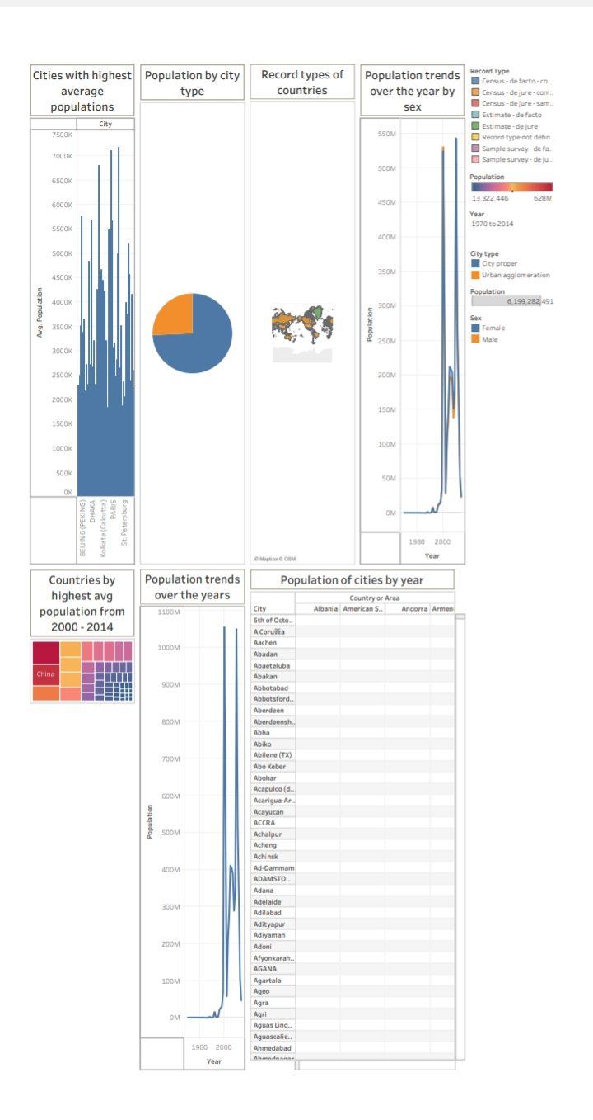



**MILESTONE 5 :** (DASHBOARD)

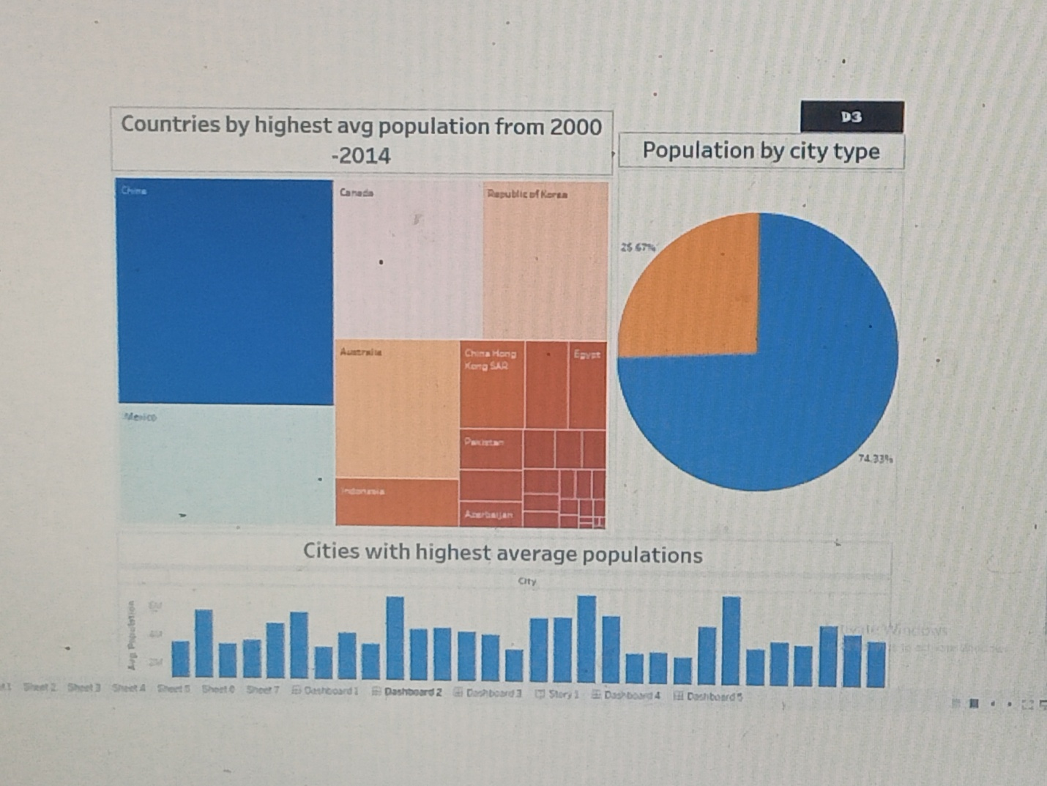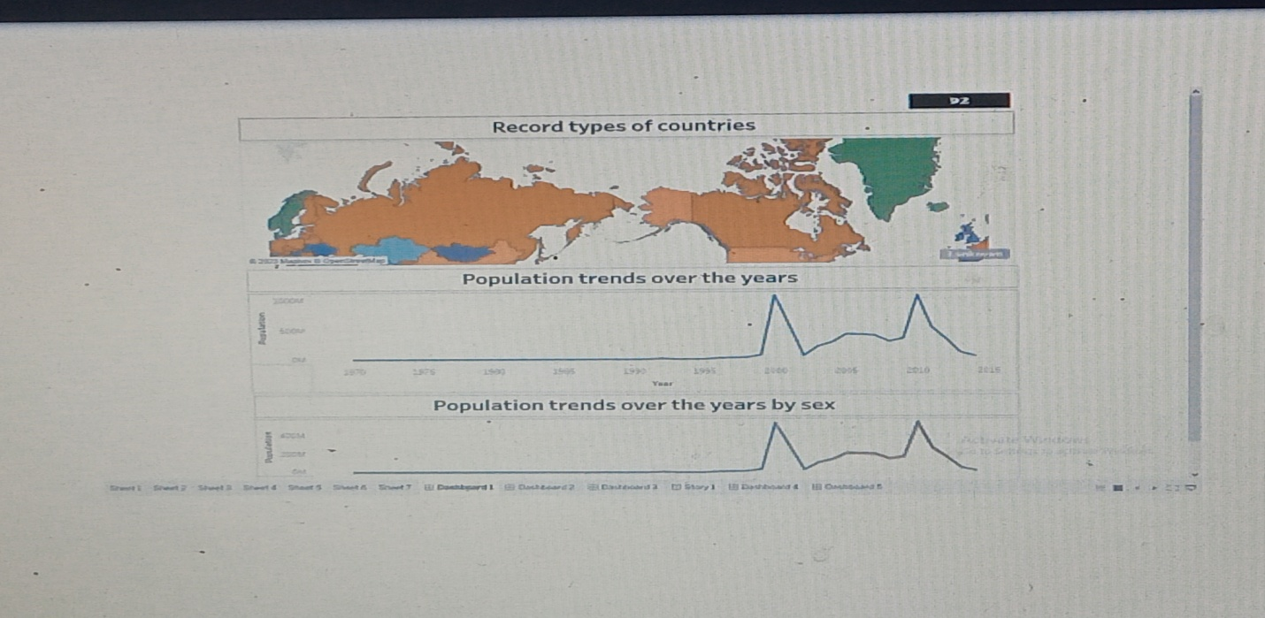



**MILESTONE 6 :** (STORY)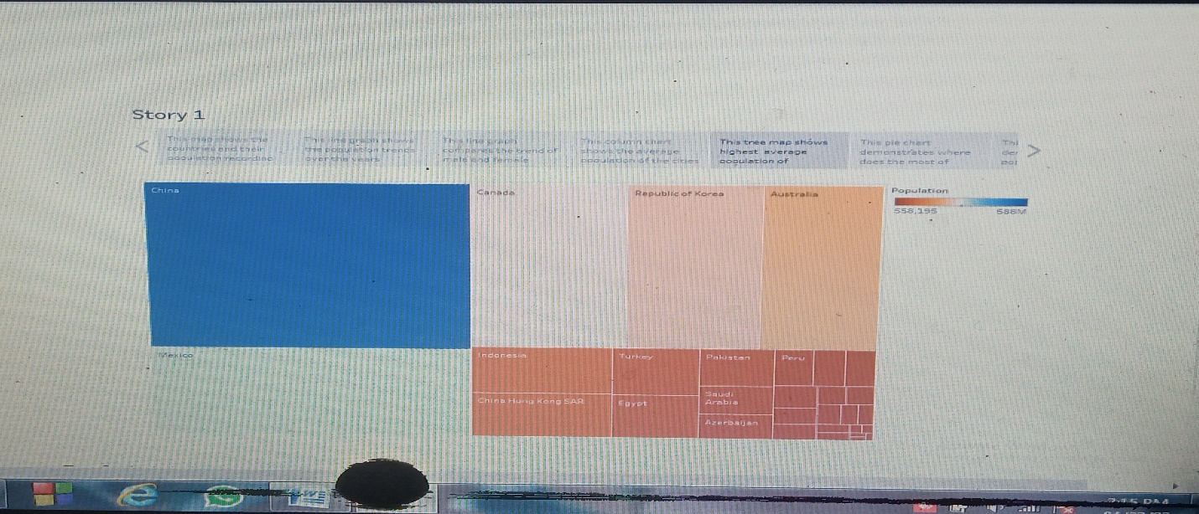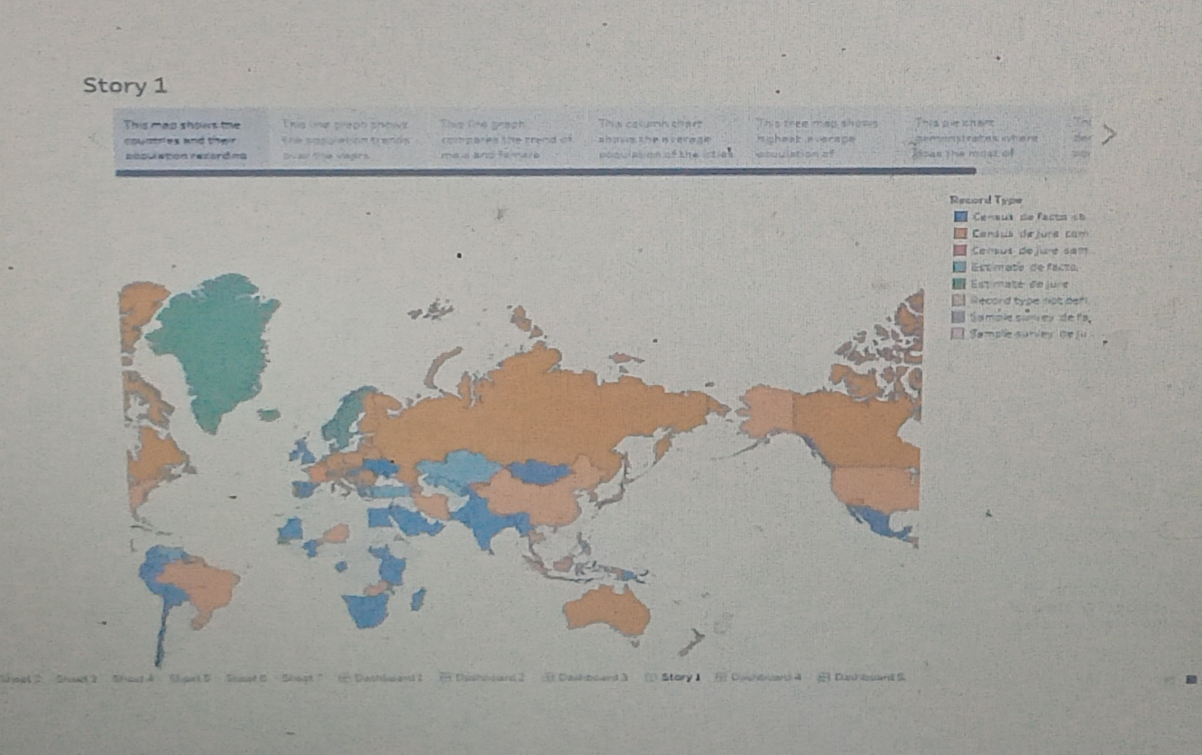



**MILESTONE 7 :** (PERFORMANCE TESTING)

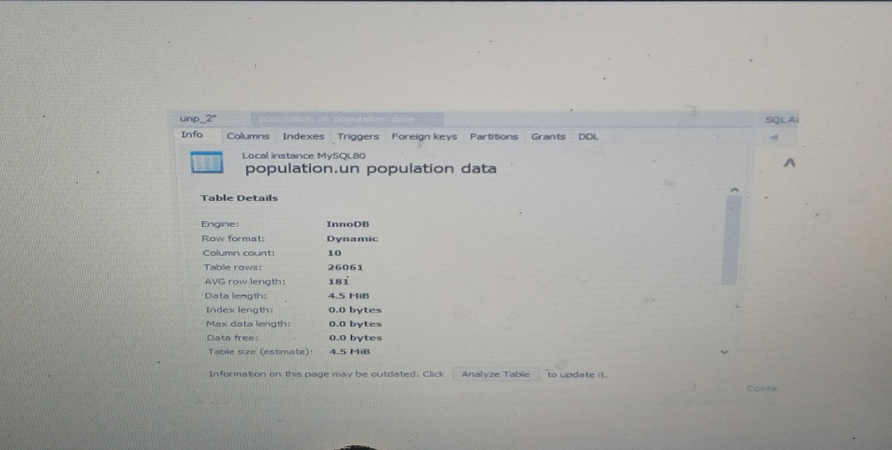

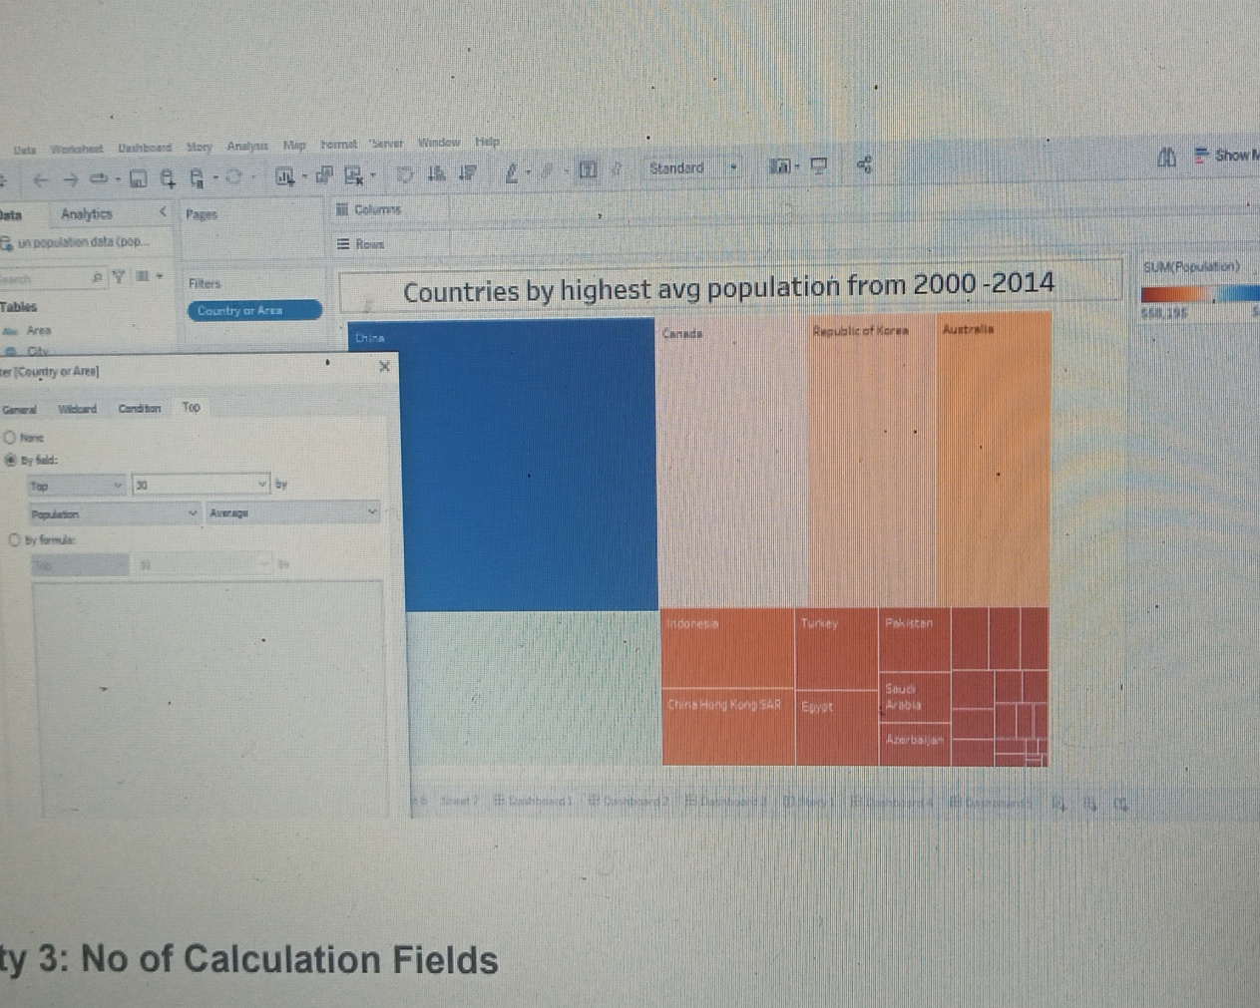



**MILESTONE 8 :** (WEB INTEGRATION)

URL LINK

Sakthi : <https://prod-apsoutheast-a.online.tableau.com/#/site/sakthir12ab/home>

Soundharya : <https://prod-apsoutheast-a.online.tableau.com/#/site/souat2003/home>

Sasikala : <https://prod-apsoutheast-a.online.tableau.com/#/site/sasiat123/flows/219489/overview>

 Sharmila : <https://prod-apsoutheast-a.online.tableau.com/#/site/sharmiat12/home>

**4. ADVANTAGES**

* Insight creation
* Learning from past mistakes
* Cost decrease
* Effective handling of uncertainty
* Balanced work load
* Facilitates planning

**DISADVANTAGES**

* Time consuming
* Never accurate
* Resource – intensive
* Accuracy in forecasting
* Inadequate information
* Arbitrary



**5. APPLICATIONS**

* Supply chain management
* Climate change
* Customer demand planning
* Forecasting of broad economic trends
* Sales and technology forecasting

**6. CONCLUSION**

* Thus, forecasting involves a proper demand and forecasting enables better planning and utilization of resources for business to be competitive.
* Forecasting is an integral part of demand management since it provides an estimate of the future demand and the basis for planning and making sound business decisions.
* A summary of a detail forecast uses item-level data and predicts future sales in terms of both item quantities and sales amounts. A summary forecast uses summary data to predict future sales.

**7. FUTURE SCOPE**

* The scope of the forecasting depends upon the operated area of the firm , present as well as what is proposed in the future.



* Forecasting can be at an international level if the area of the operation is international.
* Forecasting helps to set goals and plan ahead to have accurate data and statistics to analyze helps businesses to decide what amount of change, growth or improvement will be determined as a success.